

**1947**

**Walchand College of Engineering, Sangli**

(An Autonomous Institute)

(AY 2024-25)

**Department of Computer Science and Engineering**

A Project Synopsis on

**Enhancing Online Shopping:**

**A Virtual Try-On Solution**

For the Degree of

**Bachelor of Technology**

In

**Computer Science and Engineering**

by

Mr. Anurag Takalkar (21510016)

Mr. Onkar Yemul (21510017)

Mr. Omkar Auti (21510042)

Mr. Akash Metkari (22520012)

Under the guidance of

**Prof. Vaibhav Mali**

Department of Computer Science and Engineering,

Walchand College of Engineering, Sangli

**Problem Statement**

#### To develop an application that solves the problem of online shoppers struggling to see how clothing will fit and look, reducing uncertainty, returns, and dissatisfaction by providing a more realistic and engaging virtual try-on experience before purchase.

#### 

#### 

#### 

#### 

#### 

#### 

#### 

#### 

#### 

#### 

#### **Abstract**

#### In the current landscape of online shopping, a significant challenge customers face is the inability to physically try on clothing before making a purchase. This limitation leads to uncertainty regarding the fit, style, and appearance of garments on an individual’s body, resulting in a high rate of returns and dissatisfaction. Existing e-commerce platforms lack a seamless and realistic virtual try-on experience that allows customers to visualize how clothing items will look on them, ultimately reducing confidence in online purchases. Our project addresses this issue by developing a sophisticated virtual try-on feature for e-commerce platforms. Utilizing advanced AI and machine learning techniques such as image segmentation, geometric matching, and generative modeling, this project offers a realistic and interactive solution that allows users to visualize how clothing will look on them. By enhancing the online shopping experience, this innovation aims to boost customer confidence, reduce return rates, and provide a competitive advantage for e-commerce platforms. The project also emphasizes scalability, user privacy, and continuous improvement, ensuring a modern and effective solution to a common problem in the industry.

#### 

#### 

#### 

#### 

#### 

#### 

#### 

#### 

#### 

#### 

#### 

#### **Related Work**

#### E-commerce platforms are continuously evolving to address the significant challenges consumers face when shopping for clothing online. One prominent area of research is the development of virtual try-on (VTO) technologies that leverage advanced image processing and machine learning techniques to enhance the customer shopping experience. A literature survey of this field reveals several important contributions and advancements that inform the present project on the E-commerce Clothing Virtual Try-On Experience.

#### Numerous studies have conducted surveys on the current landscape of virtual try-on technologies, identifying crucial challenges that hinder broader adoption. These challenges often include issues related to fit accuracy, clothing deformation, and user experience. For instance, the inability of existing systems to provide realistic try-on experiences frequently results in high return rates due to customer dissatisfaction [1].

#### Machine learning techniques, particularly convolutional neural networks (CNNs) and generative models, have made significant strides in the realm of virtual try-ons. Research has demonstrated that models such as Mask R-CNN and U-Net are effective for body segmentation tasks, allowing for more precise virtual fitting of garments [1][2][3]. Furthermore, generative networks like VITON and TryOnGAN have been proposed to enhance the realism of the synthesized try-on images by accurately deforming clothing items to conform to the user's body shape [4][5].

#### Numerous works emphasize the importance of robust data collection and preprocessing for effective virtual try-on systems. It is critical to gather diverse datasets that include a wide variety of clothing styles and body types. Studies suggest utilizing platforms such as DeepFashion and Fashion-MNIST to obtain labeled datasets that encompass a range of clothing attributes and user characteristics [6][7]. Thorough preprocessing techniques, including data cleaning and normalization, are essential for improving model performance and accuracy in virtual try-ons, as highlighted by existing literature [8].

#### The evaluation of virtual try-on systems is critical for assessing their performance and user satisfaction. Existing studies propose metrics such as Intersection over Union (IoU) for segmentation performance and user-focused metrics, including perceived realism and satisfaction, for the overall virtual try-on experience [9]. A recent survey highlighted the need for standardized evaluation frameworks to facilitate comparisons among different virtual try-on methodologies [10].

#### Research has also explored how virtual try-on technologies impact consumer behavior. A study showed that VTO significantly enhances user engagement, leading to higher confidence in purchasing decisions, thus mitigating the common challenge of online shopping uncertainty [11]. Virtual try-ons can lead to increased conversion rates while reducing return rates, making them a valuable feature for e-commerce platforms [12].

#### With the rise of augmented reality, many projects integrate AR capabilities into virtual try-on systems to create immersive shopping experiences. For example, several applications allow users to view clothing items in real-time as they overlay digital garments onto themselves using smartphone cameras [13]. Innovations in AR are projected to drive further advancements in the virtual try-on landscape as e-commerce continues to merge physical and digital experiences[14].

#### In summary, this literature survey on virtual try-on technologies highlights the continuous advancements made in this field. Current challenges related to fitting accuracy, model integration, and consumer engagement are being addressed through innovative machine learning techniques and data collection methods. By building upon these findings, the E-commerce Clothing Virtual Try-On Experience project aims to deliver a robust and user-friendly solution that enhances online shopping experiences.

#### 

#### 

#### 

#### **Objective**

### **Data Collection and Preprocessing**: Tocollect dataset from official website like Kaggle

### **Model Integration and Fine-Tuning:** Use pre-existed model and Generative Model like VITON

### **Model Evaluation and Deployment****:** To check performance metrics like Precision, Accuracy, User satisfaction

### **Continuous Improvement and Adaptation:** Can use 3D Model, Images

### **Ensuring Scalability and User Privacy:** Can use blurring of images, Advanced dataset

#### 

#### 

#### **Methodology**

The methodology for developing the Virtual Try-On Experience for an E-commerce Clothing Website involves several stages of data processing and machine learning techniques. Each step is designed to enhance the accuracy and realism of the virtual try-on experience.

#### 

Fig. Methodology

#### **1. Pre-processing**

* **Objective**: To prepare input images for further processing.
* **Input**:
  + Image of a person (I)
  + Image of clothing (P)
* **Process**:
  + Capture high-quality images of a person and clothing items.
  + Standardize and normalize images to ensure consistent dimensions and lighting.
  + Use image enhancement techniques to improve the clarity of the input images.
* **Output**:
  + Two standardized images labeled (I) for the person and (P) for the clothing.

#### 

#### **2. Segmentation Generator**

* **Objective**: To segment the person’s image to isolate regions where the clothing will be fitted.
* **Input**:
  + Image (I)
* **Process**:
  + Utilize a deep learning-based segmentation model (e.g., U-Net or Mask R-CNN) to identify and segment the person’s body parts such as torso, arms, and legs.
  + Perform post-processing to refine the segmentation mask.
* **Output**:
  + Segmented image labeled (S), where the regions of interest (ROIs) are clearly delineated.

#### **3. Clothes Deformation**

* **Objective**: To deform the clothing image to fit the shape and posture of the segmented person’s image.
* **Inputs**:
  + Image (P) and segmented image (S)
* **Process**:
  + Apply a geometric matching module to warp the clothing image based on the segmented regions of the person’s image. This module, denoted as Warp(·), utilizes thin-plate spline (TPS) or affine transformation techniques for deformation.
  + Ensure that the deformed clothing aligns with the contours and orientation of the segmented body parts.
* **Output**:
  + Deformed clothing image labeled (W(c, θ)), which matches the shape and posture of the segmented image (S).

#### **4. Try-On Synthesis**

* **Objective**: To synthesize a realistic composite image combining the deformed clothing with the segmented person’s image.
* **Inputs**:
  + Segmented image (S) and deformed clothing image (W(c, θ))
* **Process**:
  + Use a generator network (e.g., ALIAS Generator) to blend the deformed clothing onto the segmented person’s image.
  + Apply post-processing techniques such as color correction, shadow blending, and edge smoothing to enhance realism.
  + Utilize adversarial training with a discriminator network to ensure the synthesized output is indistinguishable from real images.
* **Output**:
  + Final composited image that represents the virtual try-on experience, where the clothing appears naturally fitted onto the person.

This methodology outlines a systematic approach for implementing a virtual try-on experience on an e-commerce platform. By leveraging advanced machine learning techniques such as image segmentation, geometric matching, and generative modeling, the proposed system can provide a highly realistic and engaging user experience, potentially increasing user satisfaction and conversion rates on the website.

#### 

#### **Outcomes:**

#### **Development of a Robust Virtual Try-On System:**

#### **Real-Time Fitting Experience:** Implementation of a real-time virtual fitting system that allows users to try on clothes virtually, providing a realistic and interactive shopping experience.

#### **Accurate Size and Fit Recommendations:** Integration of size and fit recommendation algorithms to ensure users receive accurate advice on how different clothing items will fit their specific body shapes and sizes.

#### **Integration with E-commerce Platforms:**

#### **Seamless Integration:** Development of APIs and plugins to seamlessly integrate the virtual try-on system with existing e-commerce platforms, enabling retailers to offer this feature without overhauling their current systems.

#### **Customization Options:** Offering customization options for retailers to adapt the virtual try-on system to match their brand identity and specific needs.

#### **Enhanced Fashion Detection and Synthesis Capabilities:**

#### **Advanced Image Processing:** Implementation of advanced image processing techniques for fashion detection, including semantic segmentation, human pose estimation, and landmark detection, to accurately identify clothing items and body parts.

#### **Realistic Clothing Swapping:** Development of algorithms for realistic clothing swapping between different images, maintaining the integrity of body poses and shapes..

#### **User-Friendly Interface:**

#### **Intuitive Design:** Designing a user-friendly interface that is easy to navigate, allowing users to quickly and effortlessly try on clothes virtually.

#### **Interactive Features**: Incorporating interactive features such as zoom, rotate, and change poses to give users a comprehensive view of how the clothes will look on them.

#### **Comprehensive Performance Metrics:**

#### **Quality Assessment:** Implementation of comprehensive performance metrics to evaluate the accuracy, realism, and user satisfaction of the virtual try-on system.

#### **Continuous Improvement**: Using feedback and performance data to continuously improve the system, addressing any issues and enhancing its capabilities.

#### **Future Research and Development:**

#### **Ongoing Innovation:** Establishing a framework for ongoing research and development to keep the virtual try-on system at the forefront of technological advancements in the fashion industry.

#### **Collaboration with Academia:** Collaborating with academic institutions to explore new methods and technologies that can be integrated into the system to improve its functionality and user experience.

#### 

#### **Project Diagrams**

* **Functional Diagram**
* **Use Case Diagram**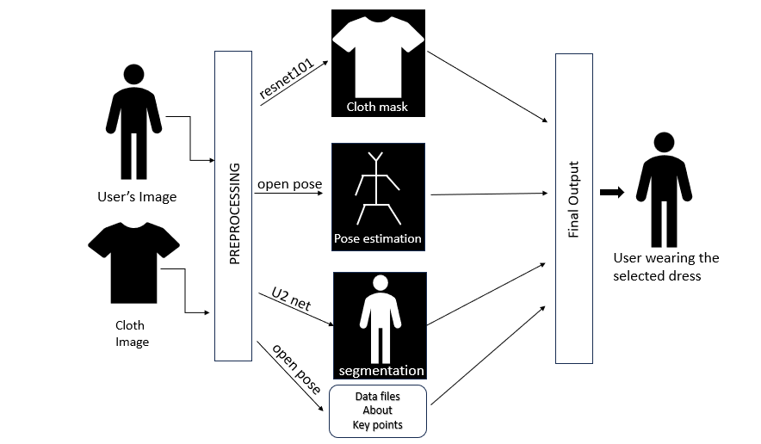

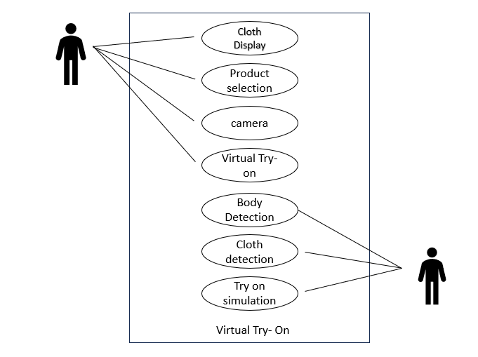

**Application:**

* **Online Shopping:**

1. Enhancing the online shopping experience by providing consumers with virtual try-on systems, allowing them to see how clothes look on them before purchasing.
2. Reducing return rates and improving customer satisfaction by offering a more personalized shopping experience.

* **Fashion Retailers:**

1. Assisting fashion retailers in optimizing sales processes and technological purchasing methods.
2. Implementing virtual fitting rooms to engage customers and drive more informed purchase decisions.

* **Fashion Analysis:**

1. Utilizing AI-powered tools for fashion detection, analysis, and synthesis, enabling advanced applications like fashion recommendation systems, automated garment tagging, and personalized fashion advice.

* **Virtual Fitting Rooms:**

1. Developing intelligent systems that can swap clothes between different images of persons while dealing with variations in body poses and shapes.
2. Creating a high level of reality and comfort in virtual fitting systems, making the online shopping process more akin to in-person shopping.

**Project Potential:**

* **Technological Advancement:**

1. Contributing to the advancement of AI and deep learning methods in the fashion industry.
2. Pushing the boundaries of current image-based virtual fitting systems to achieve more realistic and accurate results.

* **Industry Impact:**

1. Providing valuable insights and tools for the fashion industry to enhance their online retail strategies.
2. Helping fashion brands to implement innovative digital products that cater to the evolving needs of consumers.

* **Research Contributions:**

1. Offering a comprehensive survey of existing research, identifying gaps, and suggesting future research directions.
2. Contributing to the academic community by providing a detailed review of the state-of-the-art methods and their applications in the fashion industry.

* **Consumer Experience:**

1. Improving the overall shopping experience for consumers by providing them with accurate, real-time virtual fitting options.
2. Empowering consumers to make better-informed decisions, thereby boosting their confidence in online shopping.

**References**

1. H. Kim, S. Kim, and C. R. Lee, "A Survey on Virtual Try-On Technology for Fashion," International Journal of Computer Vision, vol. 128, no. 1, pp. 67-84, 2020.
2. A. G. M. Rahman, H. A. M. Rahimi, and M. H. Rehman, "Deep Learning-based Fashion Item Segmentation and Virtual Try-On Application," Journal of Fashion Technology & Textile Engineering, vol. 8, no. 3, 2020.
3. VITON: "Virtual Try-On Network for Clothing," NeurIPS, 2018.
4. S. Zhang, Y. Gao, "TryOnGAN: Realistic Clothing Try-On by Deforming Clothing Images with Deep Learning," ACM Transactions on Graphics, vol. 39, no. 4, 2020.
5. T. H. Kim, "Image-Based Virtual Try-On for Clothes Using Deep Learning," in Proceedings of the IEEE International Conference on Computer Vision, 2019.
6. G. Liu, C. Li, "DeepFashion: Powering Robust Clothes Recognition and Retrieval," ACM International Conference on Multimedia, 2016.
7. Y. Borovetz, R. S. Jacob, "A High-Quality Image Dataset for Fashion and Clothing," IEEE Transactions on Multimedia, vol. 22, no. 10, 2020.
8. J. Wang, Z. Fan, and C. Xie, "The Importance of Preprocessing in Machine Learning Applications for Fashion," Journal of Retailing & Consumer Services, vol. 50, 2019.
9. M. Chen, "Evaluating Virtual Try-On Systems: An Emerging Framework," International Journal of Human-Computer Studies, vol. 138, 2020.
10. A. K. Gupta, "Benchmarking Methods for Virtual Try-On Evaluation: A Systematic Approach," Computer Graphics Forum, vol. 40, no. 2, 2021.
11. J. H. Kim, "Consumer Behavior in the Context of E-Commerce Virtual Try-Ons," Journal of Business Research, vol. 112, 2020.
12. E. K. Song, T. Byun, "The Impact of Virtual Fitting on Customer Satisfaction: Evidence from E-commerce," Journal of Marketing Research, vol. 57, no. 1, 2020.
13. L. Zhang and H. Zhang, "Augmented Reality for E-Commerce: Transforming the Shopping Experience," Journal of Interactive Marketing, vol. 45, 2019.
14. S. P. Chen, "Future Trends in AR and Virtual Shopping Experiences," Retail Technology Review, vol. 10, no. 1, 2021.